Dear Parents/Guardians, May 6th to 10th, 2024

Happy Sunday Everyone!

May 5th is the National Day for Awareness for Missing and Murdered Indigenous Women, Girls and Two-Spirit People (MMIWG2S), also known as Red Dress Day. On this day, the nation honours the lives of missing and murdered Indigenous women, girls and gender diverse people and supports grieving families and community healing. This year four classes from Ruth King took part in the second annual Red Dress Walk along with students and staff from three others schools. It was a powerful event! Thank you to all the families who also joined in the walk.

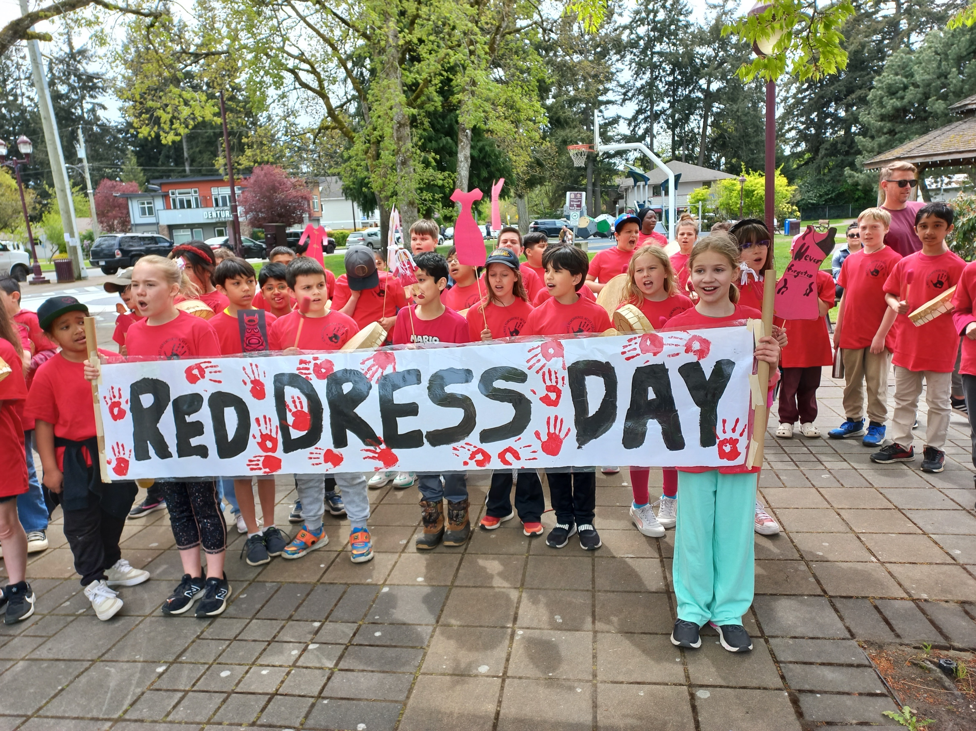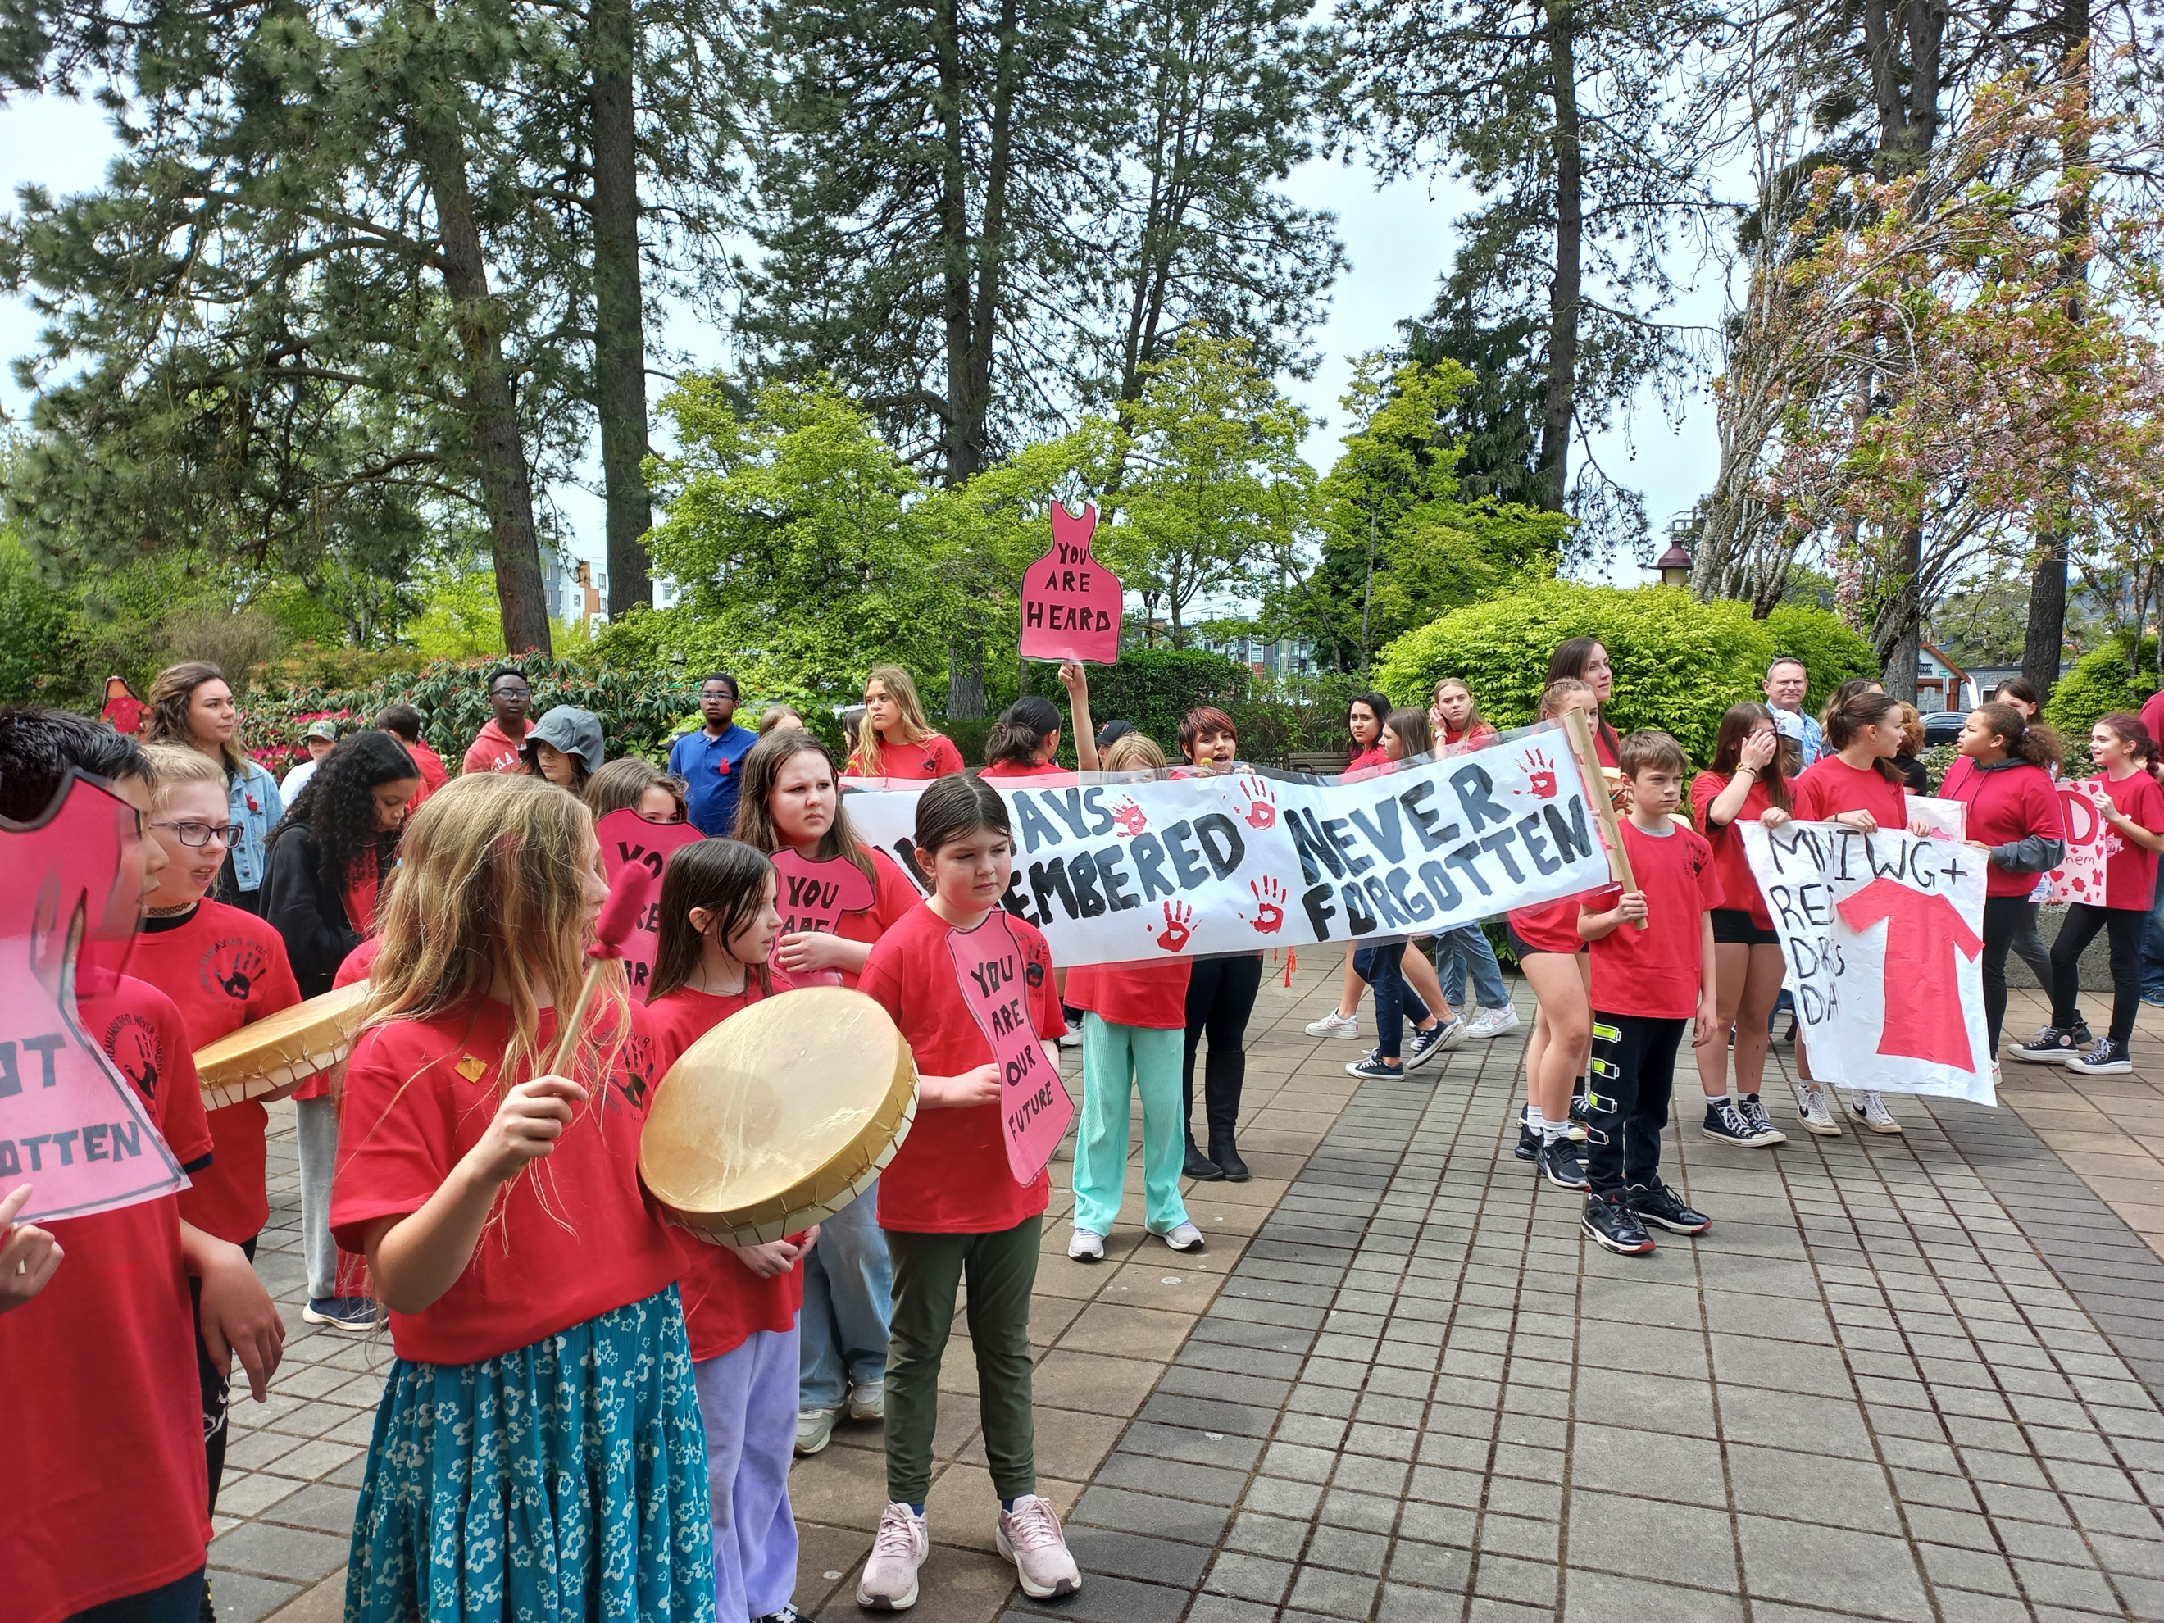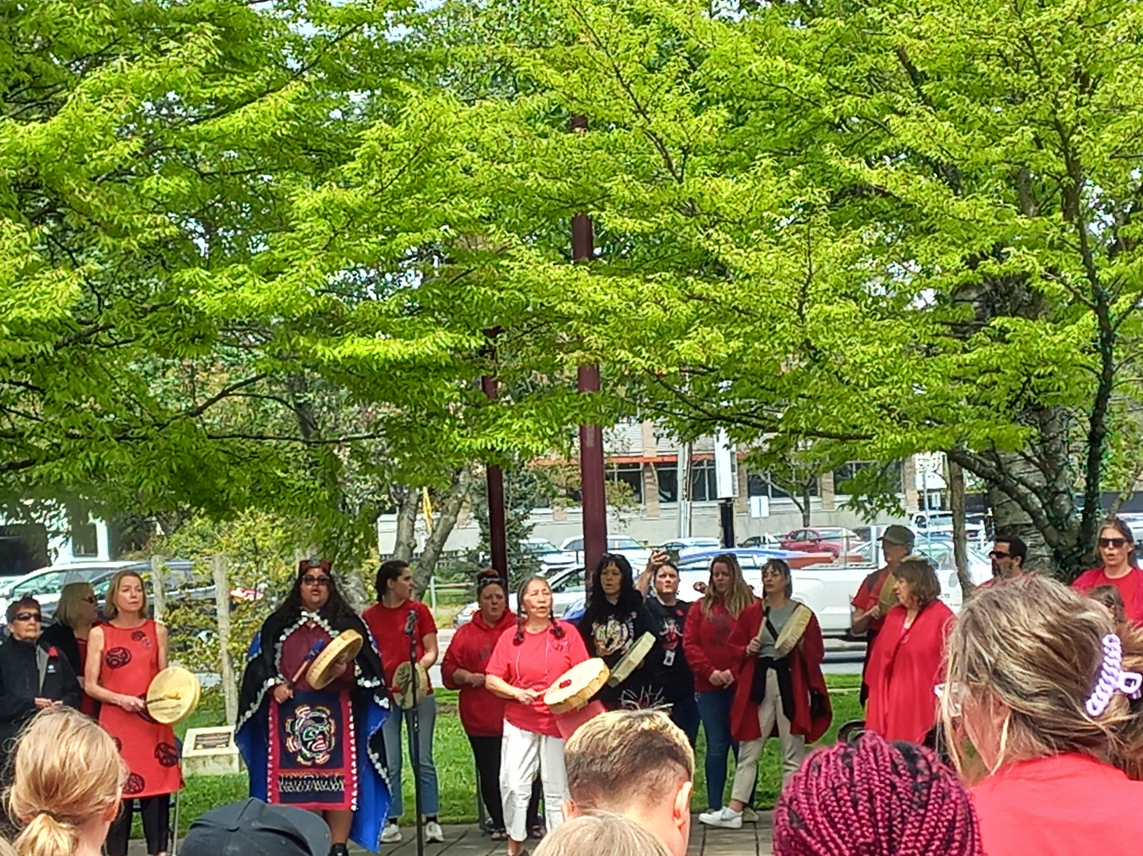

Reminders:
- Please remind your child not to bring toys from home and this includes sports equipment. The PAC and school are working together to buy more outside equipment. This will help alleviate sadness when their toys get broken or misplaced. Thank you for your help with this.
- If your child is bringing a bike/scooter to school, please make sure they have a lock for their bike/scooter. There have been incidents in the past where bikes have been stolen right off the playground during the day. It does not happen often, but it has.
- No Dogs on the playground during school hours 8:00am to 3:00pm.
- School ends at 2:23pm, please try to be here to pick your child up on time. More and more children do not have a pick up at the bell. This is becoming a huge issue for the staff at Ruth King who have meetings and other commitments at the end of the school day. Our day does not end at 2:23pm and we have work to do in planning for your children. Thank you for your understanding.

This Week:

6 Monday – Morning Meeting 8:45am (gym)

7 Tuesday – Boys Soccer at Ruth King against Sangster @ 3:00pm

8 Wednesday –

9 Thursday – Girls Soccer at David Cameron @ 3:00pm
- Whole School Photo Day

10 Friday – Grade 4/5 Track and Field event at the school at 8:45am
- Boston Pizza Day (more than just pizza)-PAC

Upcoming Events:
MAY
14 Earthquake Drill @ 9:45am
14 PAC Meeting – 6:30pm (virtual)
15 Girls Soccer Jamboree @ John Stubbs 3:00 to 5:30pm
16 Boys Soccer Jamboree @ John Stubbs 3:00 to 5:30pm
17 Pro D - Non-Instructional Day – CUPE
20 Victoria Day – No School
22-23 Spring Concert
27 Morning Meeting 8:45am (gym)
28 Public Board Meeting - 7:00pm
31 Tropical Tourist Day
31 Welcome to Kindergarten Day – in the gym
31 PAC event – Family Fun Night (Games on the field and movie in the gym)

JUNE
7 White Spot Lunch - PAC
3 Morning Meeting 8:45am (gym)
11 PAC Meeting – 6:30pm (Library in person)
14 Rainbow Day
14 FUN Day – ice cream truck/sprinklers
17 Morning Meeting 8:45am (gym)
21National Indigenous Day
24 Last day of Strong Start
25 Public Board Meeting - 7:00pm
26 Beach Day – Esquimalt Lagoon
27 Final Summary Reports go home
27 Last Day of school for students!
28 Administrative Day, Schools close

