RUTH KING NEWSLETTER - May 13th to 17th, 2024

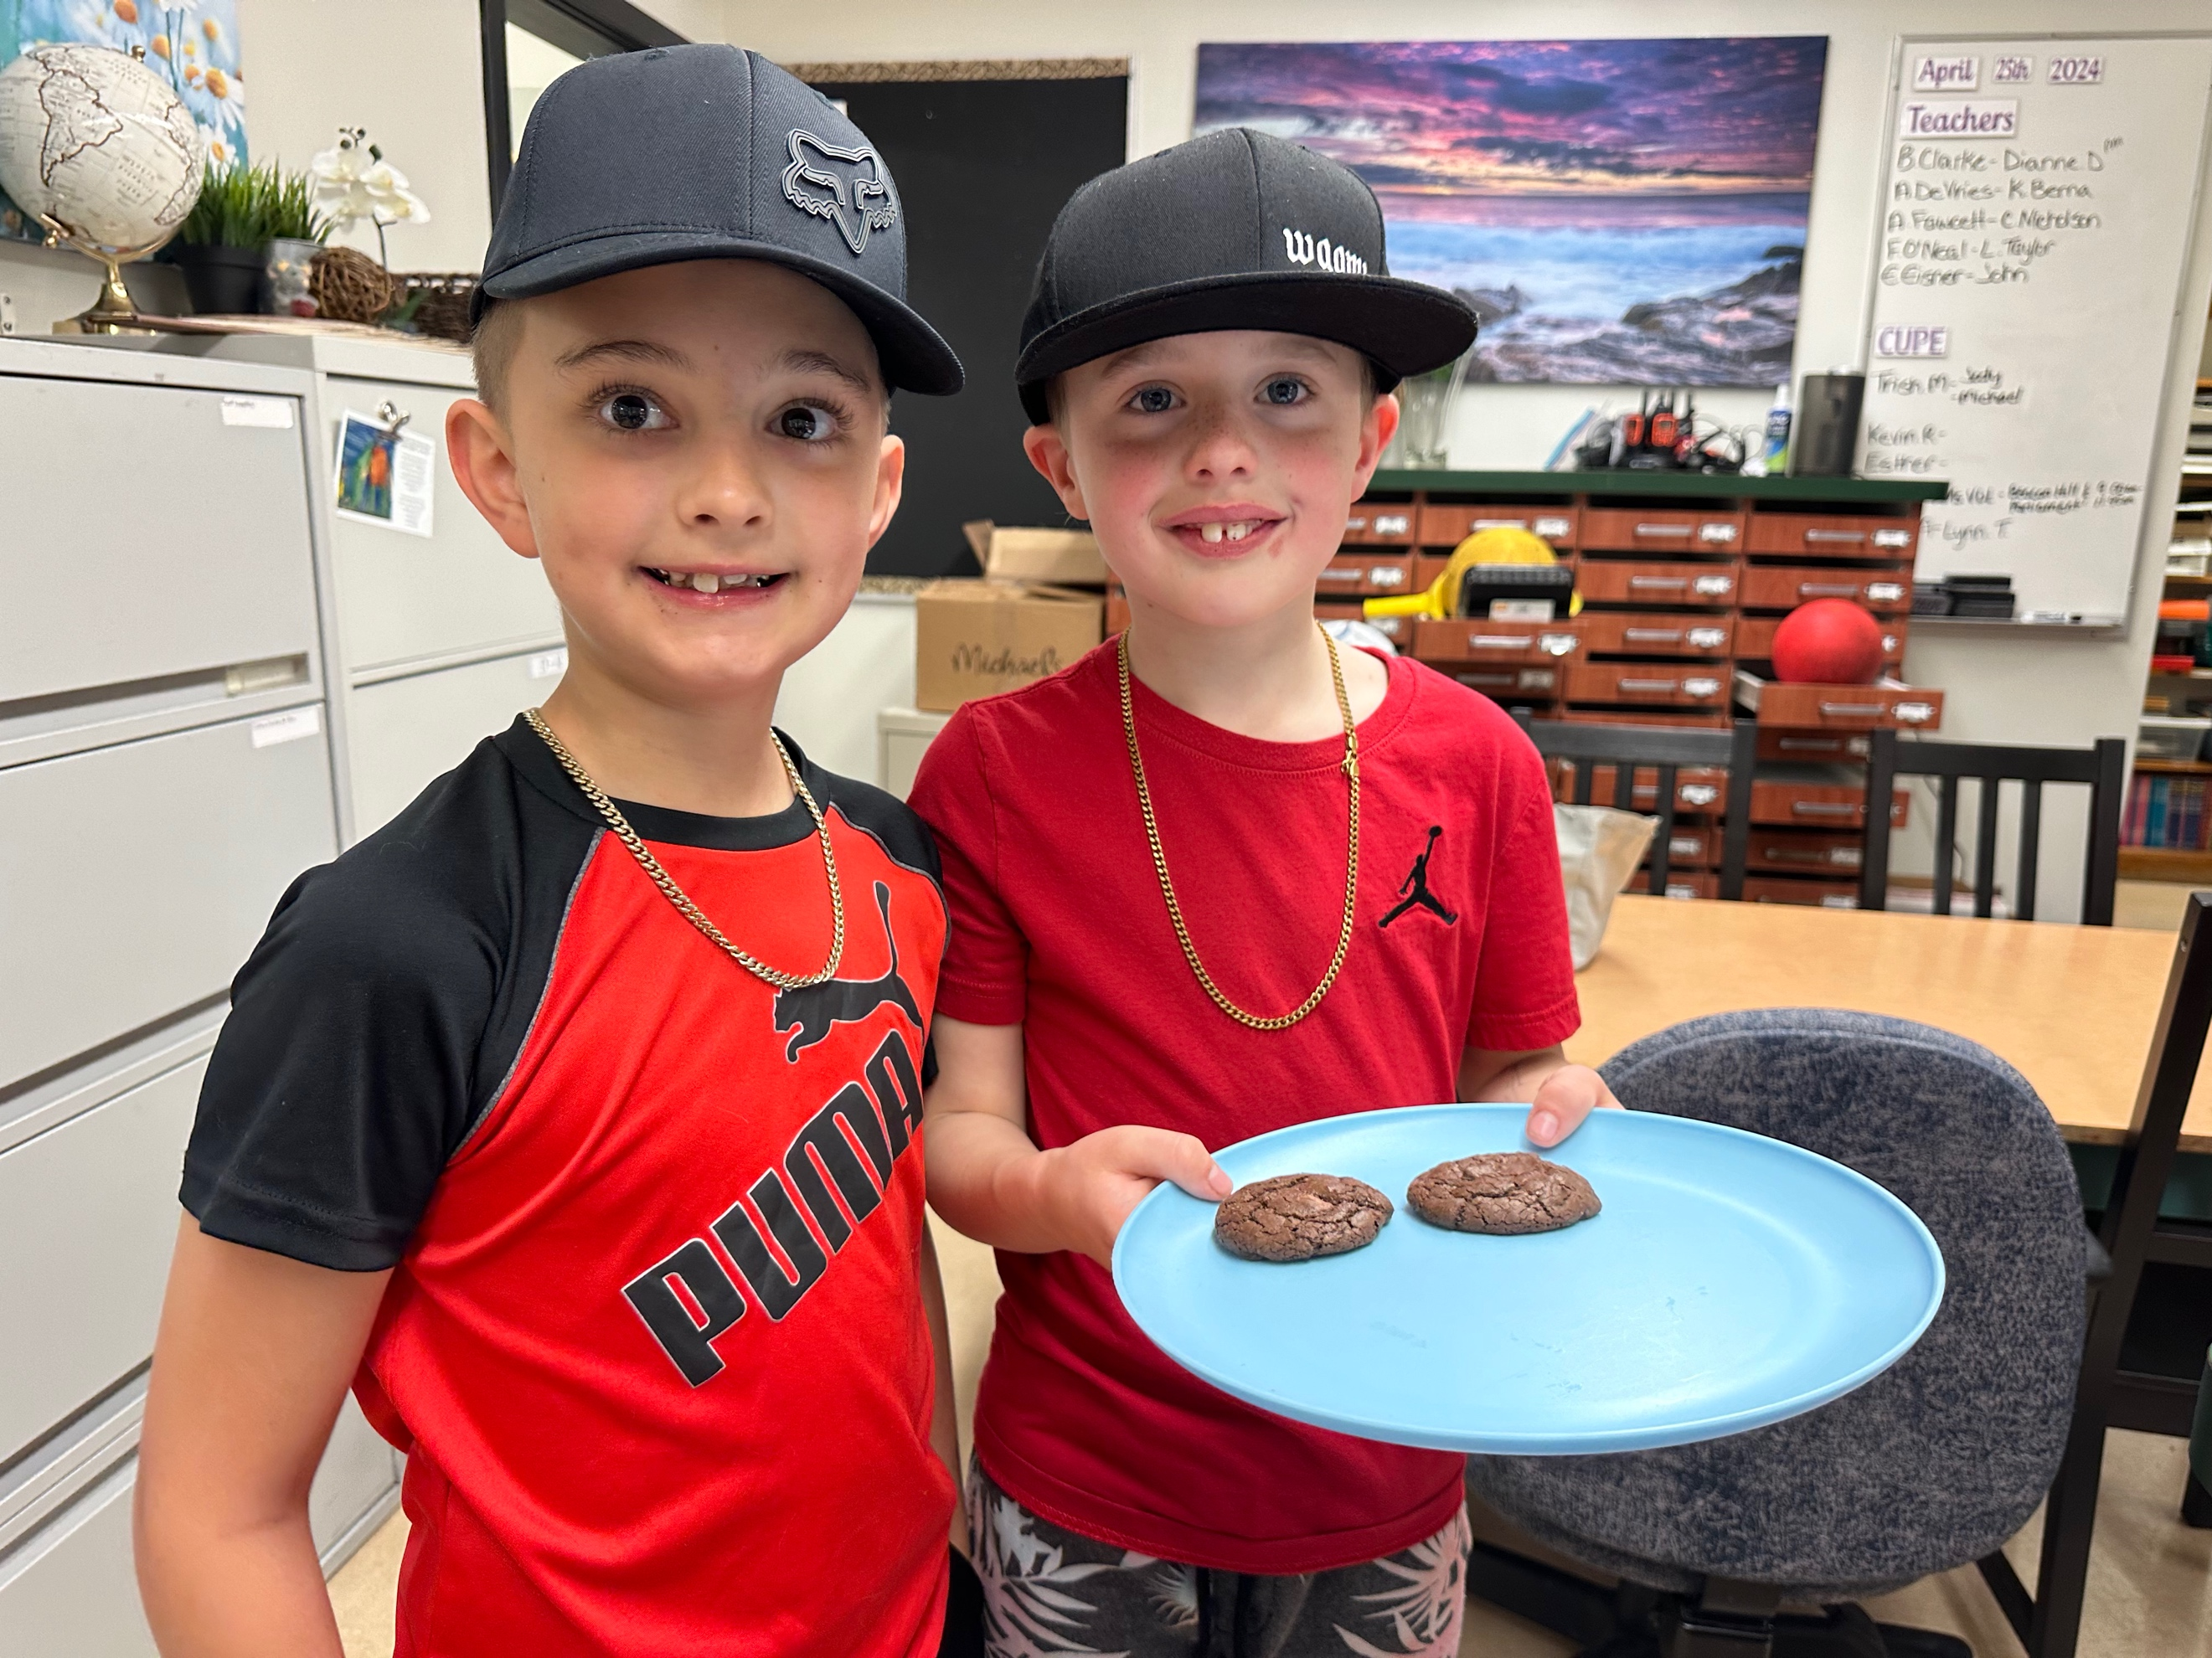Dear Parents/Guardians,



Happy Sunday everyone and

Happy Mother’s Day to all

the mom’s out there!

Jaxx and Jayce made cookies and served them to various staff.

***Reminders:***

1. Please make sure to fill out the Spring Concert ticket order forms.
2. Please remind your child not to bring toys from home and this includes sports equipment. The PAC and school are working together to buy more outside equipment. This will help alleviate sadness when their toys get broken or misplaced. Thank you for your help with this.
3. If your child is bringing a bike/scooter to school, please make sure they have a lock for their bike/scooter. There have been incidents in the past where bikes have been stolen right off the playground during the day. It does not happen often, but it has.
4. No Dogs on the playground during school hours 8:00am to 3:00pm.
5. School ends at 2:23pm, please try to be here to pick your child up on time. More and more children do not have a pick up at the bell. This is becoming a huge issue for the staff at Ruth King who have meetings and other commitments at the end of the school day. Our day does not end at 2:23pm and we have work to do in planning for your children. Thank you for your understanding.

***This Week:***

**13 Monday** –

**14 Tuesday** - PAC Meeting – 6:30pm (virtual)

* Earthquake Drill @ 9:45am

**15 Wednesday** – Girls Soccer Jamboree @ John Stubbs 3:00 to 5:30pm

**16 Thursday** – Boys Soccer Jamboree @ John Stubbs 3:00 to 5:30pm

**17 Friday** – Professional Development Day – no school for students.

***Upcoming Events:***

**MAY**

20 Victoria Day – No School

22-23 Spring Concert

**27 Morning Meeting 8:45am (gym)**

28 Public Board Meeting - 7:00pm

**31 Tropical Tourist Day**

31 Welcome to Kindergarten Day – in the gym

31 PAC event – Family Fun Night (Games on the field and movie in the gym)

**JUNE**

7 White Spot Lunch - PAC

**3 Morning Meeting 8:45am (gym)**

11 PAC Meeting – 6:30pm (Library in person)

**14 Rainbow Day**

14 FUN Day – ice cream truck/sprinklers

**17 Morning Meeting 8:45am (gym)**

21National Indigenous Day

24 Last day of Strong Start

25 Public Board Meeting - 7:00pm

26 Beach Day – Esquimalt Lagoon

27 Final Summary Reports go home

27 Last Day of school for students!

28 Administrative Day, Schools close