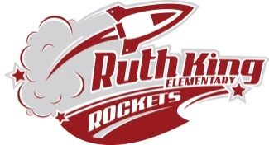
Ruth King Elementary September 2022-23
Kindergarten Supply List

Please explain to your child that the items below are collected and shared by everyone in the class.
DO NOT LABEL the following items.
2 Primary (fat red) pencils
1 large box of Kleenex
2 black Sharpies (fine or thick)

1 Box of Large Ziplock freezer bags (boys)
1 Box of medium Ziplock freezer bags (girls)
1 Pair round tip scissors
8 large glue sticks
1 bottle of school white glue
1 package of 4 expo whiteboard markers
1 White erasers (White Staedtler or Faber Castell)
- 2 24 pack Crayola Crayons
2 12 pack Crayola thick washable markers
2 blank exercise book 23cm x 18cm (no lines - Blue)
1 ½ Interlined, ½ plain exercise book (Green)
1 Each color - red, yellow, blue, and green paper duo tangs (3 holed tabs)-no plastic
Please label the following items with your child’s name.

1 Hilroy Studio Coil 35.6 X 27.9 cm scrapbook
1 Double pocket plastic folder for carrying notices home
1 pair of runners (NO Black Soles)
1 In case of wet/muddy accidents a change of clothing in a gym bag
1 Backpack or school bag – large enough for a lunch, water bottle, books etc.
1 Water bottle with lid (non-spill)
Additional supplies maybe requested once your child is assigned to a class.
The cost will be under $10.00

