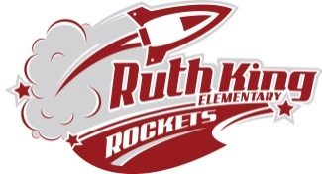
Ruth King Elementary September 2022-23
Grade 2 Supply List

Please purchase ONLY materials below to start your child off in September. Please note that as the school year progresses you may have to replenish some supplies as needed.
DO NOT LABEL the following items.
24 Sharpened HB quality pencils(Sanford or Dixon)
1 Crayola pastels
1 Crayola water color paints
1 large box of Kleenex
1 Fine tip black Sharpie
4 Regular tip black Sharpie
1 Pencil Sharpener (with holder
for shavings)

1 Box of Large Ziplock freezer bags
8 large glue sticks (Elmers)
1 bottle of school white glue
4 black expo whiteboard markers
4 White erasers (White Staedtler or Faber Castell)
- 1 24 pack Crayola Crayons

- 1 Sharpened set of pencil crayons
1 12 pack Crayola thick washable markers
1 12 pack Crayola fine tip washable markers
1 blank exercise book 23cm x 18cm (no lines – Blue Hilroy)
2 ½ Interlined, ½ plain exercise book (Green Hilroy)
1 Interlined exercise book 23cm x 18cm Hilroy (not half and half)
8 Three pronged duotangs– assorted colors (not plastic and not labelled)
2 Double pocket plastic folder for carrying notices home – (no prongs)
Please label the following items with your child’s name.

1 Hilroy Studio Coil 35.6 X 27.9 cm scrapbook
1 Pair of kids 5” sharp scissors
1 pair of runners (NO Black Soles)
1 In case of wet/muddy accidents a change of clothing in a labeled ziplock bag
1 Backpack or school bag – large enough for a lunch, water bottle, books etc.
1 Water bottle with lid (non-spill)
2 Boxes for holding pencils (approx.. 3”x6”x9”) to fit in school desks
Additional supplies maybe requested once your child is assigned to a class.
The cost will be under $10.00

